**Neo-sex chromosome shapes introgression in a hybrid swarm**

Silu Wang1, Matt J. Nalley1, Kamalakar Chatla1, Russ Corbett2, Doris Bachtrog1

1Integrative Biology

University of California, Berkeley

3040 VLSB, Berkeley, CA, USA 94720

2Biomolecular Engineering and Genomics Institute

University of California, Santa Crutz

Corresponding author email: dbachtrog@berkeley.edu

**Abstract**

Sex chromosomes are not only the “battlegrounds” between sexes, but also the “Great Walls” for introgression between diverging lineages. We are only beginning to understand the effect of sex chromosome evolution on speciation. Here we take advantage of the artificially generated hybrid swarms between young sister species, *Drosophila nasuta* (nas) and *D. albomicans* (alb) with one of the youngest known sex chromosomes. The most predominant genomic difference between the species, is that alb harbors neosex chromosomes formed via fusions of Muller CD (autosome) and the ancestral X and Y, while nas Muller CDs remain unfused from the sex chromosomes. We found that the neosex chromosome stood out as the strongest barrier to introgression, while facilitating alb-biased introgression in a sex-stage-dependent manner. Specifically, female hybrids showed significant alb-biased introgression throughout the generations sampled, while males showed symmetrical introgression until the last generation sampled, when alb Muller CD also increased to high frequency. Such introgression asymmetry is likely due to the advantage of the alb neo-X chromosome over nas unfused haplotype, and neo-X later facilitates the introgression of neo-Y by ensuring its meiotic pairing. The barrier effect is strongly negatively associated with local recombination rate within Muller CD, which was thought to be driven by sexual antagonistic arm race in the course of sex chromosome evolution. Together, this hybrid swarm generated from this young species pair shed light onto the dual roles of neosex chromosome in sharing introgression at species boundary.

**Introduction**

Speciation is the fundamental process that generates the diversity of life (1), yet the underlying genomic mechanism of speciation is not well-understood (2–5). There has been accruing evidence of sex chromosomes disproportionately representing genomic differentiation among diverging lineages (6–9). However, how does sex chromosome evolution facilitate genomic differentiation underlying speciation remains an open question.

The genomic mechanisms shaping introgression at species boundary of diverging and/or recently diverged lineages discloses the intrinsic mechanisms of speciation. Here we investigated the behavior of a young sex chromosome (due to the recent fusion of the autosome and original sex chromosome) over 28 generations of hybridizations between a recently diverged sister species. Hybrid swarms undergoing hybridization over multiple generations and can reveal the extent and direction of introgression in different parts of the genome.

The sister species *Drosophila albomicans* (distributed in the Asia Pacific island chain, abbreviated as alb hereon) and *D. nasuta* (occurs in West Africa, abbreviated as nas hereon), diverged around 0.15-0.5 mya (10, 11), while alb harbors one of the youngest known sex chromosome pairs (formed around 0.12 mya(13)) that are different from nas (12, 14), provides a unique opportunity to investigate the role of sex chromosome evolution in speciation. karyotype studies suggest that the fusion of alb Muller CD (an autosome) and Muller A (the ancestral sex chromosome) formed neo-X before the secondary fusion of the ancestral Y chromosome with Muller CD (15). This inference was supported by the recent population genetic analyses in which the neo-X haplotype is largely fixed within alb while neo-Ys are still polymorphic (13, 16). Regional recombination suppression and differential expression (between neo-X and neo-Y) were observed (13), which was thought to be driven by sexual antagonistic selection (17). Such process creates heterogeneity of recombination rate that could affect introgression at species boundary.

Although these species pair are allopatric and do not form secondary contact in nature, artificial hybrid swarms of this species pair provides a valuable opportunity to investigate the effect of neosex chromosome evolution on introgression between the otherwise (besides the fusions) similar lineages. Here we generated hybrid swarms of alb and nas and sequenced the samples of hybrids over 28 generations. In particular, we ask: (1) what is the extent and direction of introgression at the species boundary; (2) does the direction and extent of introgression within neosex chromosome differ than the rest of the genome; (3) does sexes differ in introgression; (4) what is the effect of local recombination suppression on introgression; if so, does such effect differ within neosex chromosome versus the rest of the genome?

**Methods**

*Hybrid swarm and sampling*

N=XX of each sex of each species were crossed to form hybrid swarm.

Plexiglass (dimension), the arena is maintained at room temperature, humidity, light-dark cycle.

Adults were sampled and sexed. Generations were determined by …

*Sequencing*

We sequenced at early generation (1-5, N=21), generation 9-12 (N=19+6+18+5), generation 16-18 (N=10+5+20), 21 (N=38), 27 (N=44), and 28 (N=37). The detailed sample size in terms of sex and generation is summarized in Table S1. Sequencing library prep facility and platform

*Sequence processing*

We trimmed the reads with quality cutoff =20, aligned the reads to the closest outgroup *D. kepluana* genomic reference with bwa (18). Individuals with less than 50,000 reads were excluded from downstream analysis.

*Reference haplotypes*

We used the existing high coverage sequencing of alb03 line (2 males: DBMN30-16_S49_L008 and DBMN30-19_S51_L008, 1 female DBMN21-D_S4_L007) and nas00 line (DBCC035C4_S68_L008, DBMN21-B_S2_L007). We aligned the reads to the same kepluana reference before genotyping with GATK 3.8. To determine alb vs nas specific alleles, we calculated allele frequency within alb and nas with VCFtools (19), and selected the sites with allele frequency difference greater than 0.3. Within alb-specific alleles, we determined whether the muller CD alleles is neo-Y or neo-X specific following our previous study (13). Briefly, we regarded neosex chromosome-specific sites as those within Muller CD that are homozygous in females and heterozygous in males.

*Ancestry calling*

Ancestry HMM was used to infer local genomic ancestry among hybrids in the hybrid swarm experiment. Following setting was employed: *-a 2 0.5 0.5 -p 0 -3 0.5 -p 1 -3 0.5 -r 0.000005*. In particular, we assumed equal parental ancestry contributions, and recombination rate being 5X10-6, and estimated the generations before present in which the ancestry pulse occurred. We first find the ancestry informative alleles of nasuta and albomicans. Then we prepared the input for ancestry HMM with a custom script. We defined 0= nasuta, 0.5 = heterozygotes, 1 = albomicans. Ancestry genotype was only called if the maximum posterior probability > 0.9, when the maximum posterior probability genotype was assigned to the locus.

*Neosex chromosome haplotyping*

Within Muller CD, we need to delineate neo-X, neo-Y, versus nas genetic blocks. To do so, we run a secondary three ancestry Ancestry HMM for sites within Muller CD, *-a 3 0.3325 0.3325 0.335 -p 0 -3 0.3325 -p 1 -3 0.3325 -p 2 -3 0.335 -r 0.000005*. Muller CD haplotype was called if the maximum posterior probability > 0.9. For each individual, we estimated the haplotype proportion (proportion of sites of each haplotype across all the haplotype-informative sites). We refer the any single haplotype with > 0.5 haplotype proportion being the neosex chromosome ‘haplotype background’ of each individual. This way, we can association between neosex chromosome haplotypes with introgression and ancestry turnover rates.

*Introgression*

We considered introgression with respect to the extent of admixture inferred with heterozygosity. Heterozygosity (*h*) was calculated as the fraction of heterozygous ancestry-informative sites within each individual. Admixture proportion (*p*) was the fraction of alb alleles across ancestry-informative sites. We calculated admixture proportion and heterozygosity both genome-wide and within each Muller element. To investigate the introgression across various muller element, we calculated Muller element-specific alb-biased introgression as

$\frac{1-2p}{1-h}$.

This alb-biased introgression index ranges ranging from -1 (nas-biased introgression) and 1 (alb-biased introgression) with zero implying equal introgression from either ancestry. It controls for the fact that hybrids with more admixed genomes (lower heterozygosity, greater deviation of *y* from 1) and signature of backcrossing (positive deviation of *x* from 0.5) are more likely to demonstrate asymmetrical introgression.

*Ancestry turnover across the genome*

We estimated ancestry turnover rate (*r*) by the number of ancestry switches across each muller element and across the genome. However, hybrids of later generations of admixture will exhibit more recombination, while backcrosses exhibit less recombination. To ensure that each class of hybrids are comparable, we employed a transformation index based on the Euclidian distance between the position of each individual and the point (0.5, 0) in the triangle plot.

$$λ= \sqrt{{(x-0.5)}^{2}+y^{2}}$$

The greater the distance, the less recombination event is expected. Thus r $λ$* is the admixture-corrected recombination estimate.

To compare ancestry turnover frequency among different Muller elements, the ancestry turnover rate per informative site was used, by ancestry switches over the number of informative sites in each Muller element. Muller F is excluded from this comparison because of the scarcity of informative sites. We employed ANOVA followed by post-hoc paired-t-test with FDR correction to test whether the corrected ancestry turnover rates were different among muller elements and among Muller CD haplotype groups.

*Genomic clines*

To detect genetic clusters that serve as barriers to gene flow, we fitted genomics clines (20). We first identified genetic clusters within which the ancestry blocks tend to co-segregate among all the hybrids detecting K-means clusters (21). Specifically, with R function *kmeans*, we iteratively incremented k (from k = 1) until 60% of the total variance was explained by between-clusters variance. Then we estimated cline parameters for each genetic cluster based on cluster-specific introgression relative to the genomic background. We focused on late generation (21, 27, 28) females, because the signature of selection tends to become more evident when the masking admixture effect becomes less pronounce after generations of recombination. Any effect on introgression (asymmetry effect and barrier effect respectively reflected by alpha and beta parameter estimates) could be partly due to the reduced recombination rate within Muller CD associated with the only inversion between the species. To evaluate such effect, we tested the relationship between within-cluster recombination rate and the estimates of introgression parameters (alpha and beta). Within-cluster recombination rate was estimated by the total number of ancestry switches within each cluster over the total number of ancestry informative sites represented by each genetic cluster (among females sampled from generation 21-28). We accounted for the background effect of different Muller element as the fixed effect. To fit the model, we employed nested regression with lme4 package (22) in R.

**Results**

*Asymetrical Introgression*

There was albomicans-biased genome-wide introgression, which was predominantly represented by Muller CD (Fig. triangle plot; Fig. BGC plot with muller cd haplotypes). Even though the genomes of many hybrids were admixed in the rest of the genome, muller CD is mostly dominated by the albomicans ancestry (Fig. 1-3), which reveals alb-biased barrier effect of muller CD relative the rest of the genome (Fig. 4, A). However, such alb-biased introgression is sex-dependent. The females were predominantly alb (neo-X, neoX) (Fig. 2, A), and thus the muller CD ancestry was significantly (95% CIs greater than 0.5) alb-biased throughout the hybrid generations we sampled (Figure 2 C). However, among males the frequency of alb (neo-X, neo-Y) haplotype gets higher in the later generation (Fig. 2, B) and thus the muller CD only became significantly (95% CIs greater than 0.5) alb-biased in the last generation sampled (Fig. 2, C). The *α* and *β* estimates ± SE of muller CD cline (Fig. 3 A) is respectively 0.102 ± 0.056, 0.476 ± 0.169.

*Recombination associated with individual Muller CD haplotypes*

Genome-wide alb-biased introgression is significantly associated with Muller CD inheritance. There was significantly less recombination rate (Fig. 4B) and greater alb-biased introgression (Fig. 4C; *FDR-corrected* < 0.05) within Muller CD than other muller element. In particular, individuals of alb (neo-X, neo-X) and (neo-X, neo-Y) showed greater alb introgression within muller CD (*FDR-corrected* < 10-6; Fig. 4D), but not for the rest of the genome (Fig. 4E, *pFDR-corrected* > 0.05). Although individuals with (neo-X, neo-X) haplotype in Muller CD harbor less ancestry turnovers than those with (nas, neoY) haplotype within muller CD (*p* < 0.05; Fig. 4F), (neo-X, neo-X) individuals had more ancestry turnovers in the rest of the genome (Fig. 4G, *pFDR-corrected*< 0.05).

*Ancestry clusters*

The k-means cluster drastically reduced the number of ancestry-informative units in each muller element (Table S1). Due to the lack of recombination within Muller CD, this chromosome was collapsed into only 6 genetic clusters each respectively represents 10728, 10519, 148818, 1, 6716, and 11622 ancestry-informative sites.

*Genomic clines*

In early generations, signatures of admixture swamps the footprints of selection which settles down in later generations. In later generations (21, 27, and 28), the genetic cluster representing the inversion within Muller CD repetitively exhibits barrier effect (positive beta values, and the 95% CIs don’t include zero) (Fig. 5, B, yellow dots). The second last genetic cluster of Muller CD and a suit of clusters towards the end of Muller E exhibit alb-biased introgression (Fig. 5, A, yellow dots), while the last genetic cluster of muller B (Fig. 5, left panel, turquoise dots) demonstrate significant nas-biased introgression. The barrier effect within muller CD is associated with low local recombination rate (Fig. 5, D), while local recombination rate did not show significant effect on beta parameter estimates in other muller element (Fig. 5, D), nor on clusters with asymmetrical introgression (reflected by alpha parameters) (Fig. 5, C).

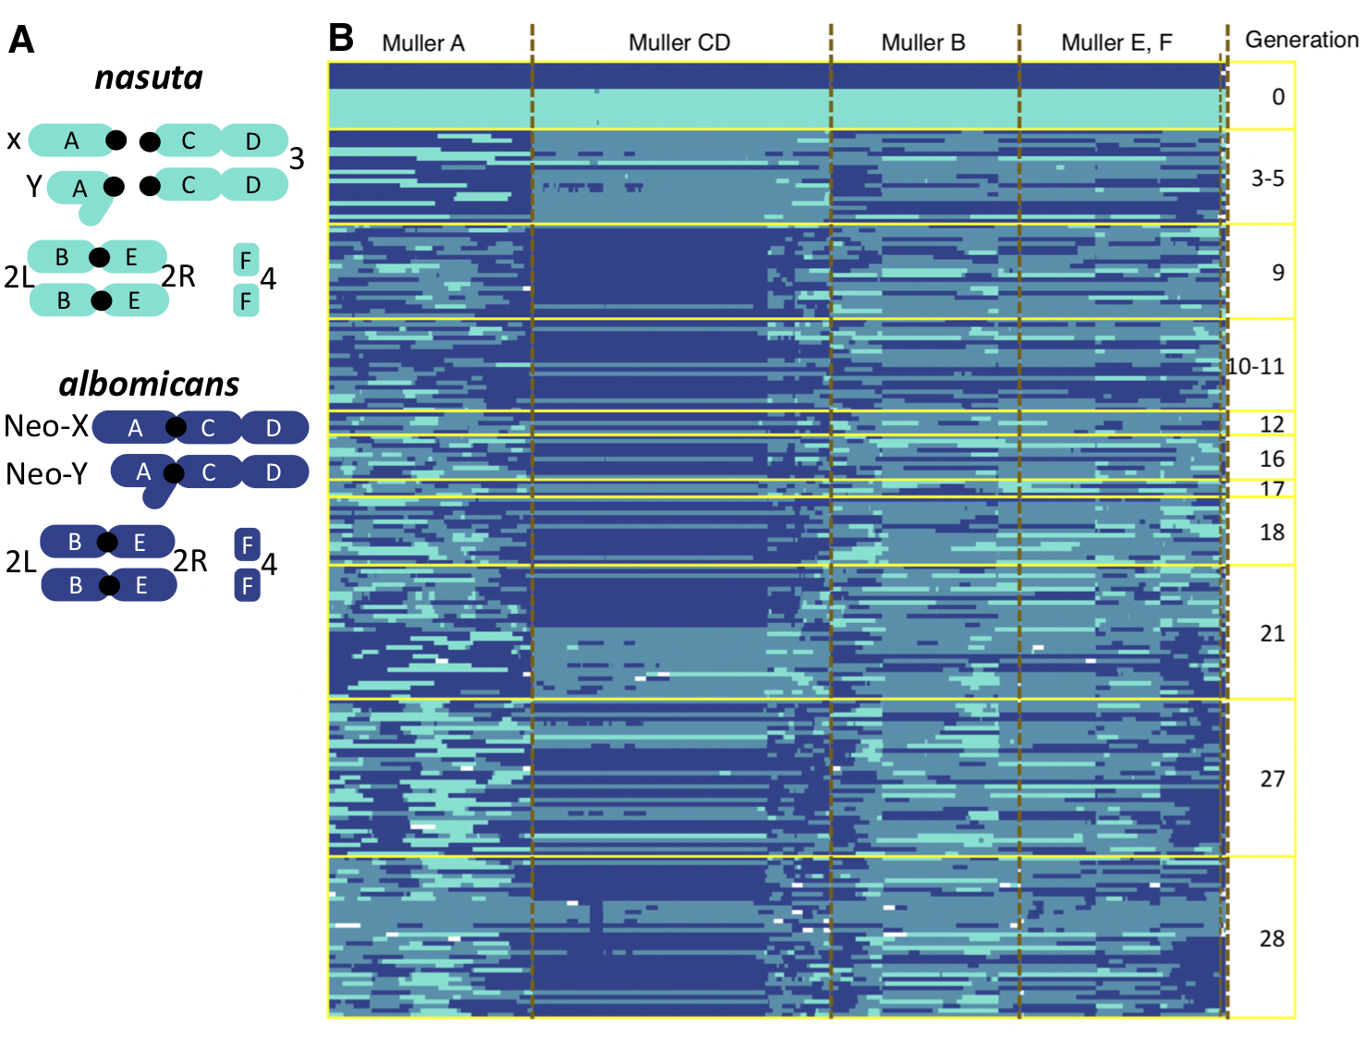

**Fig. 1** **Karyotypes and** **admixture between albomicans and nasuta ancestry.** **A**, karyotypes of alb and nas, in which the Muller CD and Muller A that are separated in nas, but fused in alb forming neo-X or neo-Y. **B**, Ancestry-HMM haplotypes of haplotypes (in columns) in hybrids of various generations (rows). The turquoise and royal blue respectively represents homozygous nasuta and albomicans genotype, and the heterozygous genotypes are represented by pale blue.



**Fig. 2 Sex-stage-dependent introgression asymmetry within Muller CD.** Muller CD haplotype proportions in female (**A**) and male (**B**) hybrids sampled from different generation**. C**, there was alb-biased proportion in female throughout the generations sampled, while males only showed alb-bias proportion in the last generation sampled. The error bars represent 95% confidence intervals.

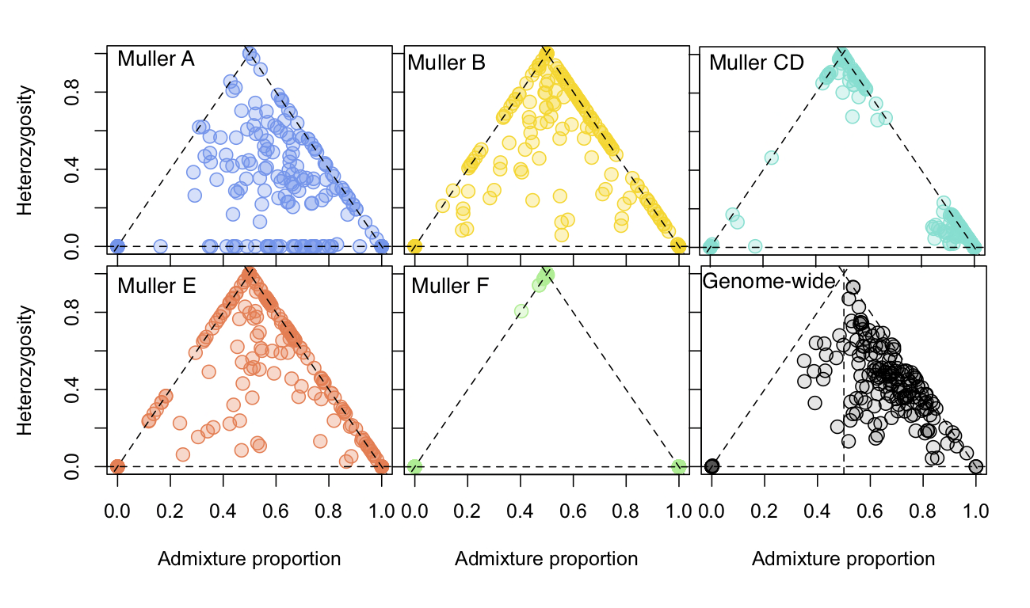

**Fig. 3** **Chromosome-specific admixture patterns.** The triangle plot with admixture proportion (pure nas =0, pure alb =1) on the x-axis and heterozygosity in different chromosome on the y-axis is variable in different muller element. In particular within Muller CD, alb-biased backcrossing is prevalent, while the same hybrids appear to be more admixed in other Muller elements.



**Fig. 4 Neo-sex chromosome inheritance underpins alb-biased introgression** **A**, Muller CD harbors barrier effect and alb-biased introgression than the rest of the genome. Muller CD demonstrates less ancestry turnovers per site (**B**) and greater alb-biased introgression (corrected for admixture, **C**) than Muller A, B, and E. **D**, There was greater alb-biased introgression (controlling for admixture) within Muller CD in individuals with (neo-X, neo-X), (neo-X, neo-Y) than individuals with other Muller CD haplotypes, but not for the rest of the genome (**E**). (**F**) There was greater haplotype switches (controlling for admixture) within Muller CD in individuals with (nas, neoY) haplotype than individuals with other haplotypes. (**G**) In the rest of the genome, individuals with (neo-X, neo-X) haplotype exhibited more ancestry switches than individuals with other haplotype. **D**-**G**, The letters “A-C” on the plots delineate significantly different (*p* < 0.05) groups (A > B > C), otherwise “N.S.” indicates no significant difference was observed among groups.



**Fig. 5 Cross-generational barrier effects and ancestry advantage at genetic clusters.** The plots demonstrate estimates (surrounded by 95% CI) of alpha (**A**) and/or beta (**B**) genomic cline parameters across K-means genetic clusters in the genome in later generations (21, 27, and 28) of hybrids. A genetic cluster in Muller CD demonstrate consistently significantly positive beta values (**B**, yellow) across generations (21 to 28), implying that this cluster is a barrier to introgression. A different set of genetic clusters (towards to the end of Muller CD and many within Muller E) turn out to show significant alb-biased introgression (**A** yellow dots, positive alpha), suggesting potential advantage of alb ancestry at these regions. In contrast, a cluster in Muller B consistently showed significant nas-biased introgression (**A** turquoise dots, negative alpha), indicating nas advantage at this genetic cluster. **C**-**D**, the association of within-clusters recombination rate (number of ancestry switches within each cluster over the number of ancestry informative sites represented by each cluster) and alpha (**C**) or beta (**D**) parameter estimates of the clusters. There was significantly negative association between within-clusters recombination rate in Muller CD and beta estimates (reflecting barrier effect) of Muller CD clusters (*p* < 0.05).

**Discussion**

By tracking alb-nas hybrid swarm over generations, we revealed the role of neo-sex chromosome in both causing asymmetrical introgression and suppression of introgression between species. The suppressive effect on introgression is associated with the recombination suppression within neosex chromosome. The additional effect of neosex chromosome on alb-biased introgression is sex-stage-dependent, consistent with that the alb neosex chromosome is advantageous over the unfused nas alternative.

*Species barrier*

Sex chromosome is increasingly recognized being the barriers of introgression across a diverse group of organisms (6–8, 23, 24). However the mechanism of such barrier effect is not well-understood. Here by tracking the behavior of the newly-formed sex chromosomes at an incomplete species boundary, we dissected the effect of sex chromosome evolution on introgression. As expected, the strong introgression barrier is within the neosex chromosome. The barrier cluster on Muller CD (Fig. 5 B) encompassing 10519 ancestry informative loci consistently demonstrates barrier effect, contains the only inversion between the sister species pair. Interestingly, the strength of the barrier effect within the neosex chromosome is significantly negatively associated with local recombination rate (Fig. 5D). After the fusion of the sex chromosome and autosome forming the neosex chromosome, reduction of recombination within the recombining pseudo-autosomal region is selected for to maintain coupling of sexual antagonistic loci (17, 25). Such step-wise suppression of recombination rate can also prevent introgression of heterospecific variants. In addition, heterospecific sexual antagonistic combinations might be especially harmful, leading to selection against hybrids. The relative paucity of (nas, neoY) individuals supports this idea.

*Asymmetrical introgression*

In addition of barrier effect of neosex chromosome, we also observed asymmetrical introgression associated with the neosex chromosome. Asymmetrical introgression (alb-biased) is not simply explained by the reduction of recombination rate within the neosex chromosome. Interesting, such asymetricl introgression occurred in a sex-specific, stage-specific manner. The Muller CD of hybrid females were predominantly alb-like, while the male hybrids demonstrated even partition of alb and nas ancestries (Fig. 2, C). However, at the last generation sampled, alb neosex chromosome became abundant, revealing alb-biased introgression in males as well. The alb-biased introgression within muller CD might suggest advantage of alb variant over the nas variant. The fused alb neosex chromosome is thought to be advantageous over the unfused primitive haplotype (15), because otherwise the neosex chromosome would not have increased to high frequency, given that it has to overcome the meiotic structural incompatibility. This observation is also consistent with the fact that advantageous parental form tends to be dominant in the hybrid genome (26).

*Step-wise prevalence of neo-X and neo-Y*

An interesting side observation of this study is the step-wise prevalence of (neo-X, neo-Y) haplotype in males (Fig. 2). The (neo-X, nas) was more prevalent in early generation hybrid males, but the (neo-X, neo-Y) haplotype blocks appeared in later generation hybrids. This is consistent with the step-wise evolutionary history of the neosex chromosome, in which the neo-X formed first and as it became prevalent, it facilitated the spread of neo-Y as its meiotic pairing partner (15). Neo-Y was almost absent in earlier generations of male hybrids, which could be due to the meiotic structural incompatibility, and can only become more abundant when neo-X is more common over nas.

**Reference**

1. C. Darwin, *On the Origin of the Species* (1859).

2. B. A. Payseur, L. H. Rieseberg, A genomic perspective on hybridization and speciation. *Mol. Ecol.* (2016) https:/doi.org/10.1111/mec.13557.

3. P. Nosil, J. L. Feder, Genomic divergence during speciation: Causes and consequences. *Philos. Trans. R. Soc. B Biol. Sci.* **367**, 332–42 (2012).

4. C. R. Campbell, J. W. Poelstra, A. D. Yoder, What is Speciation Genomics? The roles of ecology, gene flow, and genomic architecture in the formation of species. *Biol. J. Linn. Soc.* **124**, 561–583 (2018).

5. O. Seehausen, *et al.*, Genomics and the origin of species. *Nat. Rev. Genet.* **15**, 176–192 (2014).

6. D. C. Presgraves, Evaluating genomic signatures of “the large X-effect” during complex speciation. *Mol. Ecol.* **27**, 3822–3830 (2018).

7. J. P. Masly, D. C. Presgraves, High-resolution genome-wide dissection of the two rules of speciation in Drosophila. *PLoS Biol.* **5**, e243 (2007).

8. M. J. O’Neill, R. J. O’Neill, Sex chromosome repeats tip the balance towards speciation. *Mol. Ecol.* (2018) https:/doi.org/10.1111/mec.14577.

9. A. Qvarnström, R. I. Bailey, Speciation through evolution of sex-linked genes. *Heredity (Edinb).* (2009) https:/doi.org/10.1038/hdy.2008.93.

10. D. Bachtrog, The speciation history of the Drosophila nasuta complex. *Genet. Res.* **88**, 13–26 (2006).

11. H.-Y. Chang, F. J. Ayala, On the Origin of Incipient Reproductive Isolation: The Case of Drosophila albomicans and D. nasuta. *Evolution (N. Y).* **43**, 11610–1624 (1989).

12. K. I. Wakahama, *et al.*, Genetic studies of the Drosophila nasuta subgroup, with notes on distribution and morphology. *Japanese J. Genet.* **57**, 113–141 (1982).

13. K. H. C. Wei, D. Bachtrog, Ancestral male recombination in Drosophila albomicans produced geographically restricted neo-Y chromosome haplotypes varying in age and onset of decay. *PLoS Genet.* **15**, e1008502 (2019).

14. T. Ohsako, T. Aotsuka, O. Kitagawa, The origins of the Japanese mainland population of Drosophila albomicans. *Japanese J. Genet.* **69**, 183–194 (1994).

15. Y. C. Yu, F. J. Lin, H. Y. Chang, Stepwise chromosome evolution in Drosophila albomicans. *Heredity (Edinb).* **83**, 39–45 (1999).

16. K. Satomura, K. Tamura, Ancient male recombination shaped genetic diversity of Neo-Y Chromosome in drosophila albomicans. *Mol. Biol. Evol.* **33**, 367–374 (2016).

17. D. Bachtrog, The temporal dynamics of processes underlying Y chromosome degeneration. *Genetics* **179**, 1513–1525 (2008).

18. H. Li, Aligning new-sequencing reads by BWA BWA : Burrows-Wheeler Aligner. *Slides* (2010) https:/doi.org/10.1002/pssa.200673542.

19. P. Danecek, *et al.*, The variant call format and VCFtools. *Bioinformatics* **27**, 2156–2158 (2011).

20. Z. Gompert, C. A. Buerkle, Bayesian estimation of genomic clines. *Mol. Ecol.* **20**, 2111–2127 (2011).

21. E. Forgy, Cluster analysis of multivariate data : efficiency versus interpretability of classifications. *Biometrics* **21**, 768–769 (1965).

22. D. M. Bates, M. Maechler, B. Bolker, S. Walker, lme4: linear mixed-effects models using S4 classes. *J. Stat. Softw.* **67**, 1:48 (2015).

23. D. E. Irwin, Sex chromosomes and speciation in birds and other ZW systems. *Mol. Ecol.* (2018) https:/doi.org/10.1111/mec.14537.

24. B. Charlesworth, J. A. Coyne, N. H. Barton, The relative rates of evolution of sex chromosomes and autosomes. *Am. Nat.* **130**, 113–146 (1987).

25. D. Charlesworth, Evolution of recombination rates between sex chromosomes. *Philos. Trans. R. Soc. B Biol. Sci.* **372**, 20160456 (2017).

26. D. R. Matute, *et al.*, Rapid and predictable evolution of admixed populations between two Drosophila species pairs. *Genetics* **214**, 211–230 (2020).

**Supplementary**

**Fig. S1** Ancestry haplotypes, each column is a SNP, each row is an individual.

**Fig. S2** ancestry haplotypes after imputation, each column is a SNP, each row is an individual. The generation number is on the right side.

Fig. S4

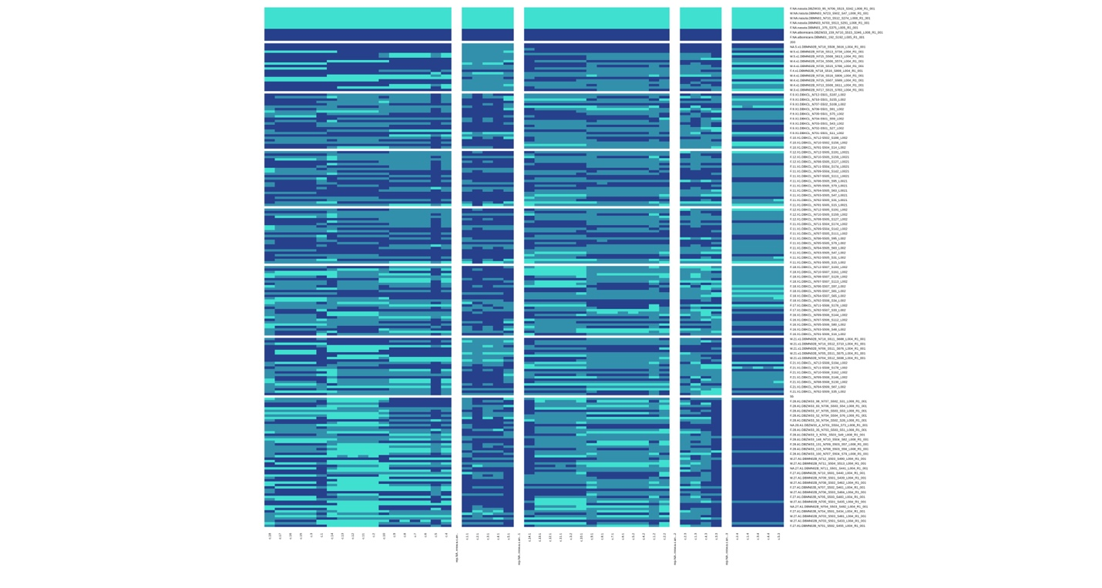

**Fig. S3** K-means clusters

**Table S1** Number of flies sequenced in each generation of the hybrid swarm with sex information.

|  |  |  |  |  |  |  |  |  |  |  |  |  |  |  |
| --- | --- | --- | --- | --- | --- | --- | --- | --- | --- | --- | --- | --- | --- | --- |
|  | Generation | **3** | **4** | **5** | **9** | **10** | **11** | **12** | **16** | **17** | **18** | **21** | **27** | **28** |
| Sex | Female | 0 | 1 | 0 | 19 | 5 | 18 | 5 | 10 | 5 | 16 | 16 | 18 | 33 |
| Male | 1 | 12 | 5 | 0 | 1 | 0 | 0 | 0 | 0 | 4 | 21 | 22 | 0 |

**Table S2** Summery of numbers of ancestry informative sites and k-means clusters across each muller element.

|  |  |  |  |  |  |
| --- | --- | --- | --- | --- | --- |
|  | **Muller A** | **Muller B** | **Muller CD** | **Muller E** | **Muller F** |
| Ancestry-informative sites | 128,670 | 120,223 | 188,404 | 126,724 | 3,036 |
| K-means clusters | 18 | 14 | 5 | 42 | 5 |